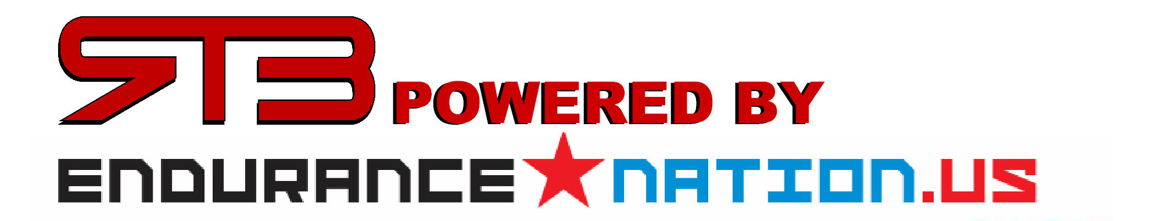

RAISE THE BAR POWERED BY ENDURANCE NATION TRAINING CAMP
RELEASE & ACKNOWLEDGMENT OF AGREEMENT

I, _____________________________, wish to participate in the Membership and Training Camps offered by Raise the Bar, LLC for the duration of the camp for which I’ve registered for. I understand there are some risks in participating in a program of strenuous exercise. Consequently, I have been examined by a physician of my choice and obtained he/her approval for my participation in this program within sixty days of the date set forth below. No change has occurred in my physical condition since the date such approval was given which might affect my ability to participate in the training camp.

I agree that Raise the Bar, LLC shall not be liable or responsible for any injuries to me resulting from my participation in the Membership or Camps and I expressly release and discharge Raise the Bar, LLC, Endurance Nation LLC, their owners, employees, agents and/or assigns, from all claims, actions, judgments and the like which I or my heirs, executors, administrators or assigns may have or claim to have as a result of any injury or other damage which may occur in connection with my participation in the Training Camp, excepting only an injury caused by the gross negligence or intentional act of such person or persons. This release shall be binding upon my heirs, executors, administrators and assigns.

In addition...

1. I understand and agree that it is my responsibility to monitor and act accordingly upon conditions or changes in my health, now and ongoing, which might affect my ability to exercise safely and with minimal risk of injury.

2. I understand that should I feel light headed, faint, dizzy, nauseated or experience pain/discomfort that I am to stop the activity and inform my Primary Care Physician.

3. I understand that I am not obligated to perform nor participate in any activity that I do not wish to do, and that is my right to refuse such participation at any time during my participation in the Camp.

4. I understand the results of any fitness program cannot be guaranteed and that my progress depends on my effort and cooperation in and outside of the Membership and/or Training Camp. I have read this Release and Terms of Agreement and understand all of its terms. I sign it voluntarily and with knowledge of its significance.

________________________________ _______________________________ _________________
Participant Signature Printed Name Date

